**Oyster Task Force Meeting Minutes**

**Tuesday, October 1, 2024, 10:00am**

**New Orleans Lakefront Airport**

**6001 Stars and Stripes Blvd.**

**New Orleans, LA**

**I.** Pledge of Allegiance

**II.** Roll call and introduction of guests

**Voting Members Present:**

Jakov Jurisic

Mitch Jurisich

Brad Robin

Brandt Lafrance

Sam Slavich

Peter Vunovich

Willie Daisy

**Voting Member Absent:**

Shane Bagala

Tracy Collins

Dan Coulon

Brandon Debarge

Al Sunseri

Matthew Slavich

Steve Pollock

**Non-Voting Members Present:**

Davis Madere

Kyle Balkum

**Non-Voting Members Absent:**

Brian Lezina

**III.** Brad Robin motioned to approve the August 28, 2024 meeting minutes, 2nd by Peter Vujnovich. Motion carries.

Brad Robin motioned to amend the agenda by taking up item item F. To Consider Funding for a Marketing Campaign with WWLTV/Tegna item A., the first item under New Business, 2nd by Peter Vujnovich. Motion carries.

Brad Robin motioned to approve the October 1, 2024 meeting agenda as amended, 2nd by Peter Vujnovich. Motion carries.

**IV.** Treasury Report

Remaining Fund Balance- $521,255

Remaining Budget Balance- $68,946

August Tag Sales- $27,600

Patrick Banks stated that he has responded to some questions from the legislative office regarding the OTF’s BA-7 request and they are currently waiting to get on the agenda to go in front of the committee

**V.** Committee Reports:

A. Public Private Oyster Seed Grounds Committee- no report

B. Enforcement Report- August 15- September 20th

**Region 4** (Iberia)

2 – Violate sanitation code (refrigeration)

**Seizures:**

4 sacks

**Region 5** (Calcasieu, Cameron, Vermillion)

Cameron

**Seizures:**

Vermillion

**Seizures**

**Region 6**: (Terrebonne, Lafourche, Grand Isle)

Terrebonne

56:444 Failure to display proper number on vessel (Tarp)

**Seizures:** None

**Region 8**: (Jefferson, Plaquemines, St. Bernard, Orleans)

**St. Bernard**

1 – take oysters from unapproved area (LDH closure due to Hurricane Francine)

**Seizures:**

20 sacks

**Plaquemines**

**Seizures:**

C. Legislative Committee Report: no report

D. Legal Committee Report: no report

E. Research Committee Report: no report

F. Coastal Restoration Committee Report:

Jakov Jurisic motioned to appointed George Ricks as the new Coastal Restoration Committee, 2nd by Brad Robin. Motion carries. Jakov, Brad Robin and Brandt Lafrance stated that they will sit on committee

G. Marketing Committee Report: Anna Koehl provided an update on planning for Washington, D.C. Mardi Gras, stated that they are maintaining social media presence and shifting focus and messaging to marketing oysters for the holidays; on hold with super bowl marketing

H. Health Committee Report: Jennifer Armentor stated that there has been 2 illnesses this month both from Florida one from May- Vibrio V, neither one resulted in a death, both had individuals had health issues and both had an out of state dealer; Mitch Jurisich thanked LDH for their efforts after the storm and getting the areas reopened after the storm

Brad Robin asked about seafood markets and the requirements surrounding serving oysters; St. Bernard will have another one on October 26th and wondering about eating oysters grilled or raw? Jennifer Armentor stated that grilled oysters are permitted through retail at LDH and will have to have a mobile unit and will need to meet requirements but for raw consumption there are no raw shucking mobile units; Health Committee meeting announced for Tuesday, October 29, 2024 for 10am at LDH offices in Baton Rouge

I. Aquaculture Committee Report: no report

J. Joint Task Force Working Group Report: no report

**VI.** New Business

1. Sandy Garcia with WWLTV provided a presentation on a marketing campaign with WWLTV/ TEGNA

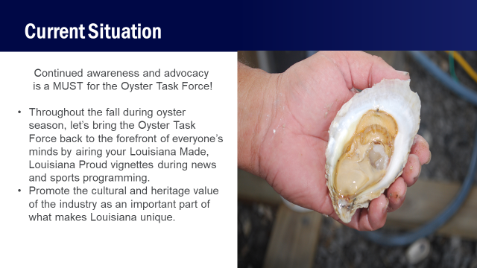

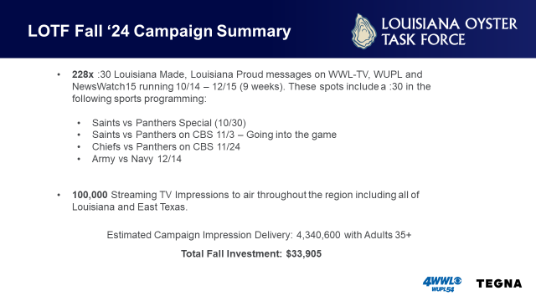

1. Gene Cavalier provided a documentary on oysters: post link; $35 a year for the labeling program; The link to LDAF’s Oyster Documentary: [https://youtu.be/OI_p59mr4Fw](https://urldefense.com/v3/__https:/youtu.be/OI_p59mr4Fw__;!!CCC_mTA!8cXGA6fNVPPOlAsaMJNX4oT269vZeOgJsRU-WeIm0sLNH6rGvuxBEh9RmplKJSz6DOCA79ApMdaKWOwn97g1qEIS8Hc$)
2. Quentin Hart provided a presentation on the Federal Crop Insurance Program for LA off-bottom oyster growers

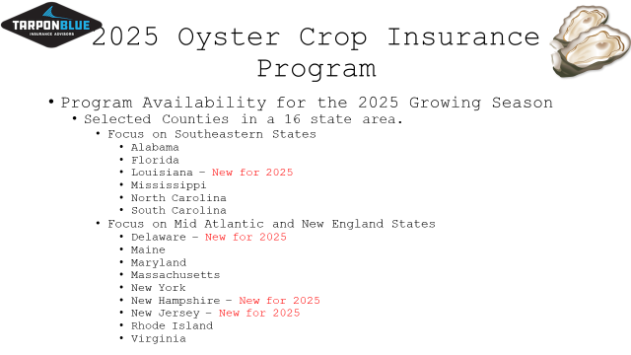

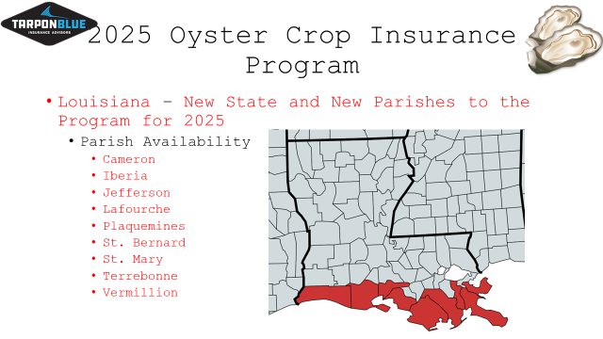

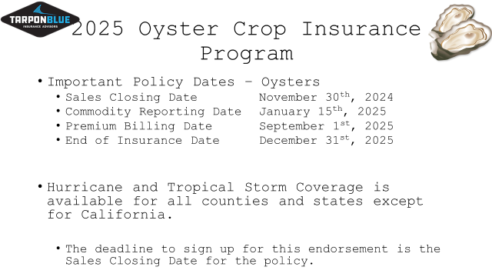

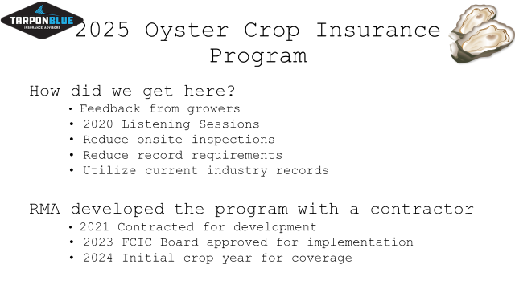

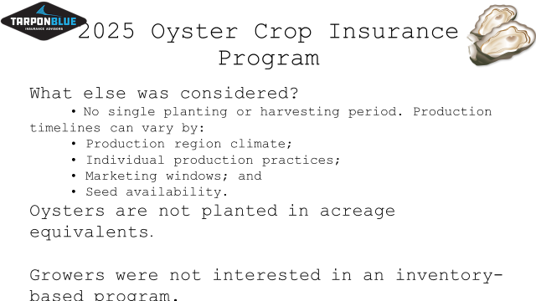

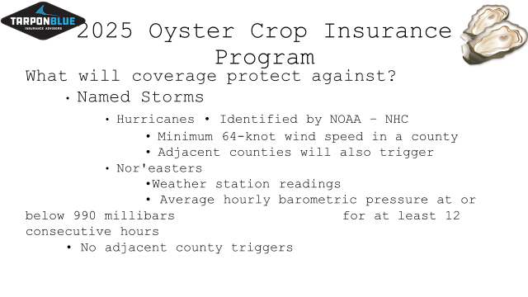

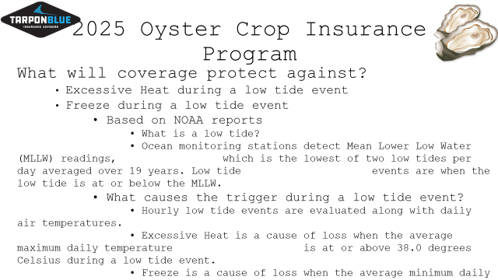

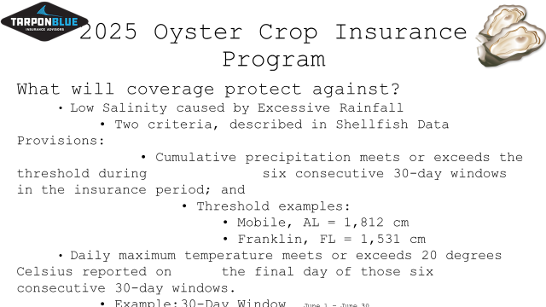

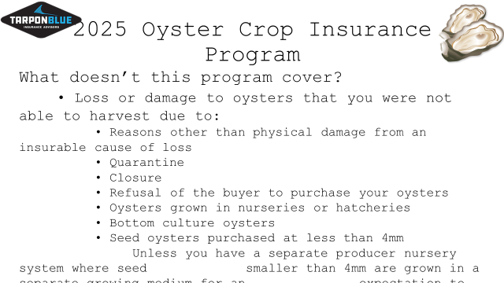

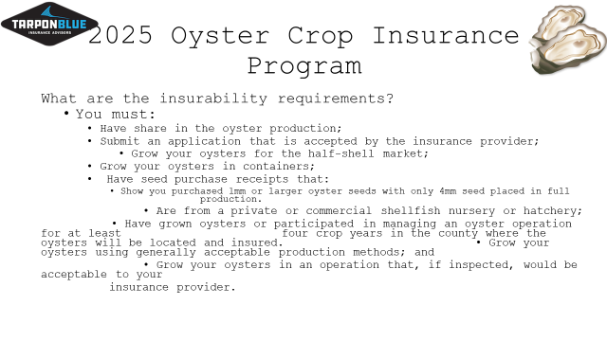

1. Robert Caballero provided an update on the oyster bedding season- 3 days long boarding run, estimates by LDWF biologists at about 11 e-reporting had 13 unique vessels reporting the majority of the harvest, where about 7,500 barrels were harvested, had about 50% compliance on the vessels participating at some point in the reporting process

Hurricane Francine impacts, did not assess the reefs north of MRGO but the rest of the areas were assessed, no impacts to sack mortality, did have some spat and seed mortality in Hackberry Bay and Calcasieu Lake areas, only observed spat set, recruitment for SW Pass eastward toward Atchafalaya Bay, news release in the next week or so; Announced new security measures for the New Orleans field office, the office will be locked down coming up for fall renewal season , waiting for more information but will be getting a security code for elevator to access the 4th floor, telephone numbers are posted in case someone needs to get upstairs

Jakov Jurisic inquired about nautical maps, stated that LDH and LDWF used to produce paper maps to plot coordinates and see where you are

1. John Bennett provided a presentation on a marketing opportunity with Gulf Coast Sports and Entertainment

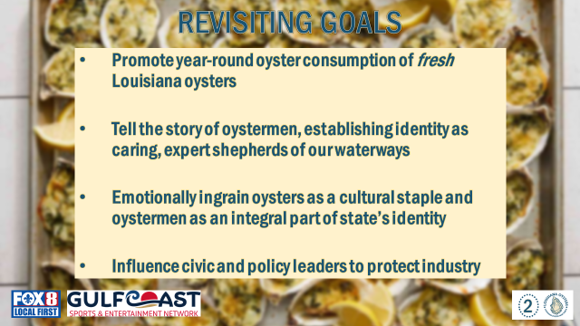

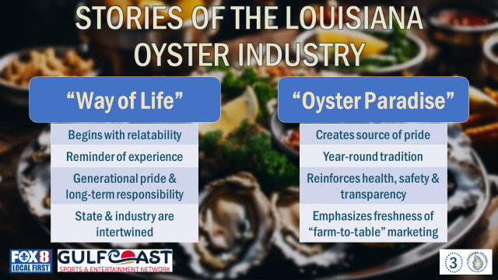

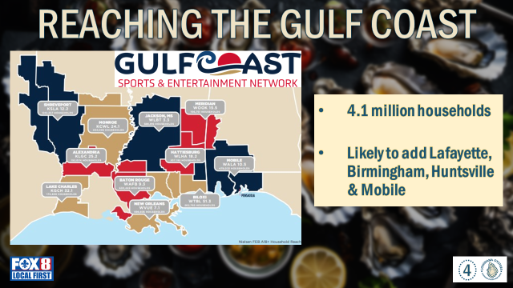

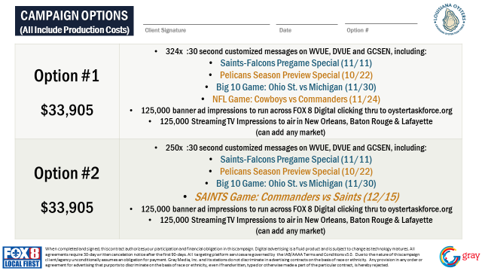

1. The task force considered funding to participate in the LA Oyster Trail Campaign

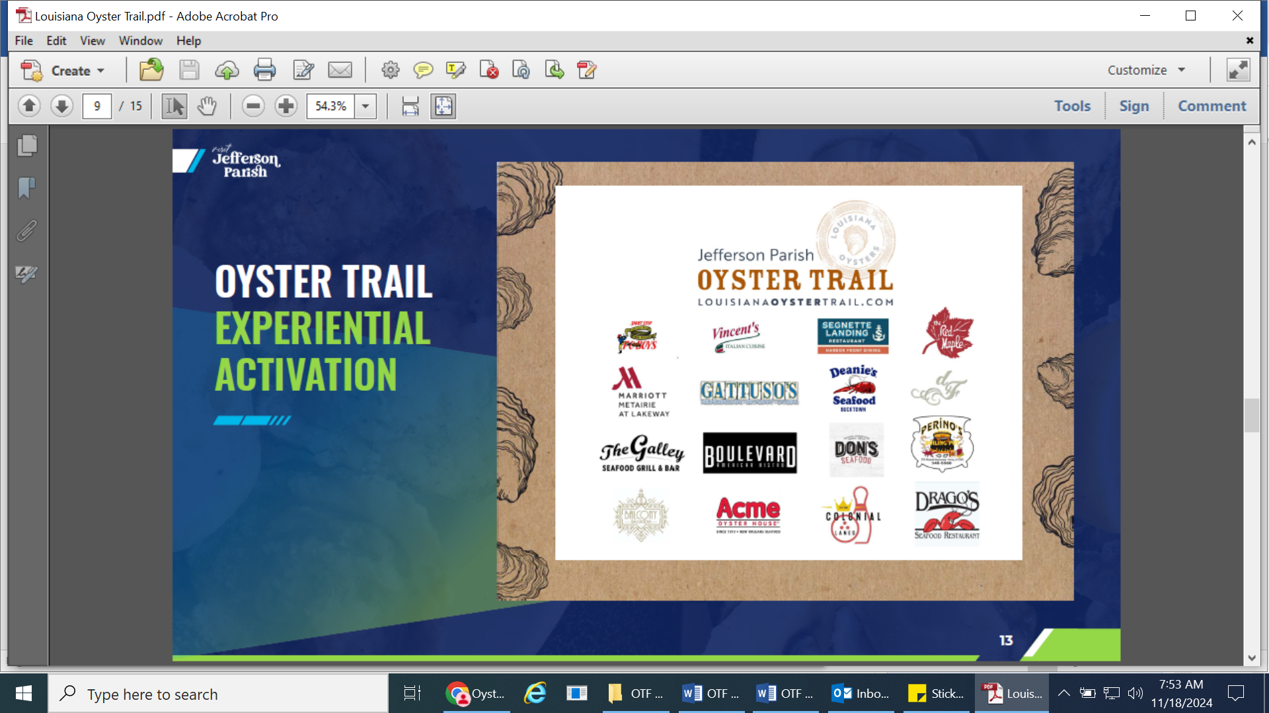

A $15,000 sponsorship that would generate millions for the LA Oyster Trail, the program spends about $30,000 annually to run the oyster trail and as we get more sponsorships, we plan to build it bigger and better

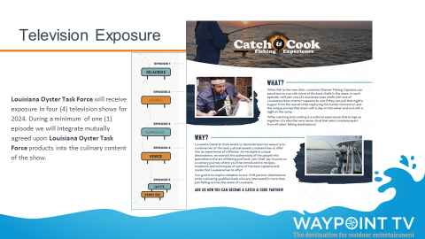

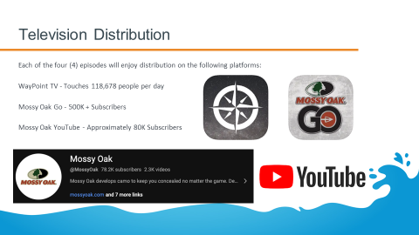

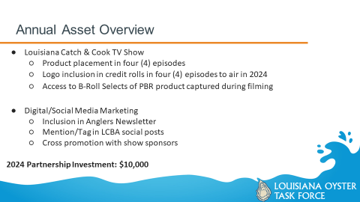

LCBA culinary side of the fishing experience, got 4 episodes looking for support the LCBA 3 day fishing charter license so budget cut asked to collaborate with other organizations, LA Catch and Cook episodes, $10,000 sponsorship would be specific to 1 quarter, 4th quarter which starts today, next year plans for 6 episodes there may be some opportunity to participate next year as well

Sam Slavich motioned to not move forward on any OTF marketing proposals at this time and to defer all of these advertising and marketing items until the BA-7 funding goes through and the task force knows where they stand financially, 2nd by Jakov Jurisic. Motion carries.

Asked that Patrick Banks stay in touch with the task force as the BA-7 progresses through the process

1. The board considered funding for the 2025 Let the World Be Your Oyster Event

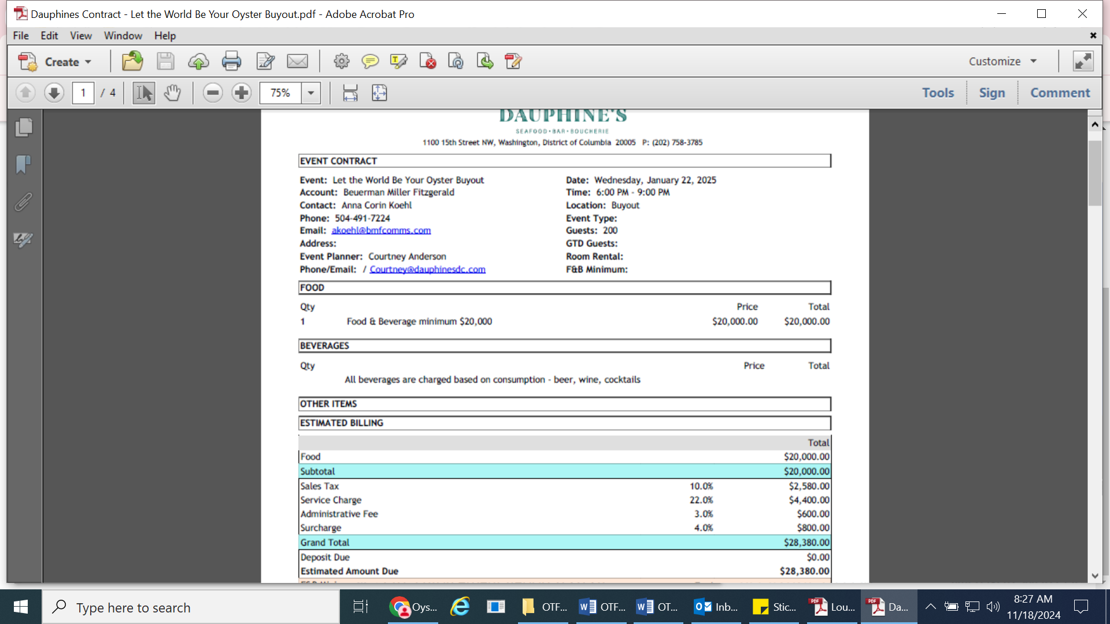

Anna Koehl stated that it will cost around $30,000 for a buyout of the venue, still need to talk to Acme and/or Drago’s to bring in oysters to sponsor the event, the event will take place at Dauphine’s Restaurant on January 22, 2025 from 6-8pm

Brad Robin motioned to reserve Dauphine’s Restaurant to host the Let the World Be Your Oyster event, 2nd by Brandt Lafrance. Motion carries.

1. The Task Force deferred item H. To Hear an Update for Possible Participation in 2025 Super Bowl Events to a future meeting

**VII.** Public Comment:

George Ricks stated that John Lane, Coastal Affairs, willing to tweak the operation of the Caernarvon Diversion meeting on the operation of the two diversions, no one from the oyster industry participated in the last meeting last year, CPRA reached out to us and they are willing to tweak the operation, the next meeting is set for December it’s very important that we have representation at this meeting, will also reach out to the Shrimp Task Force for participation, will send the meeting information over to Allison West to disperse to the OTF

Kevin Burke LCBA show, invited the task force to come and participate in the show, the LA Oyster Trail Challenge happens in November

**VIII.** Next meeting set for Tuesday, November 19, 2024 10:00am at the New Orleans Lakefront Airport

**IX.** Brandt Lafrance motioned to adjourn the meeting, 2nd by Brad Robin Motion carries.

Meeting adjourned at 12:41pm